**KGISL INSTITUTE OF TECHNOLOGY, COIMBATORE**



C PROGRAMMING AND DATA STRUCTURES

MINI PROJECT REPORT

**WOMEN SAFETY SYSTEM BY USING IOT**

Submitted by

**ADSHAYA S S [711721106007]**

**ARJUNAN R [711721106011]**

**LAKSHMI PRABHA M [711721106056]**

**MAHA DHARSHINI M [7117211060304]**

Under the guidance of

**Mrs. G. ELIZABETH RANI M.Tech**

(Assistant Professor, Department of Computer Science and Business System)



**BONAFIDE CERTIFICATE**

**This is to certify that the Mini project titled “WOMEN SAFETY SYSTEM BY USING IOT ” is a bonafide record of the work done by Adshaya S S(21ECA07), Arjunan R (21ECA10),Lakshmi Prabha M (21ECA55), Maha Dharshini M (21ECA66)carried out the project work under my supervision. Certified further that to the best of my knowledge the work reported herein does not form part of any other thesis or dissertation on the basis of which a degree or award was conferred on an earlier occasion on this or any other candidate.**

**Mrs. G. ELIZABETH RANI Dr. C.VENKATESH**

**Assistant Professor, Professor & Head of**

**Department,**

**Department of CSBS, Department of ECE,**

**KITE KITE**

CONTENTS

|  |  |
| --- | --- |
| **CHAPTER NO** | **TITLE** |
|  | **SYNOPSIS** |
| 1 | **INTRODUCTION** |
| 2 | **SYSTEM SPECIFICATION** |
| 3 | **SYSTEM STUDY** |
| 4 | **SYSTEM DESIGN** |
| 5 | **SYSTEM TESTING AND IMPLEMENTATION** |
| 6 | **CONCLUSION** |
| 7 | **FUTURE ENHANCEMENT** |
|  | **BIBLIOGRAPHY** |

**SYNOPSIS:**

Nowadays, women safety is a prime issue of our society. The count of the victim are increasing day by day. In this paper, we are proposing a model which will help to ensure the safety of women all over the global. We have used different sensors like heartbeat sensor, temperature sensor, and accelerometer sensor for detecting heartbeat, temperature and sudden change in motion of user. We have also used GPS which will help to detect location of the device. IOT used in the model is used to send alert message to guardians, relatives and police station. We have proposed Iot(internet of things) based device which will help to continuously monitor values of different sensors and GPS used in device.

**CHAPTER-1**

**INTRODUCTION**

At the present scenario Women are competing with men in every prospect of society. Women contribute fifty percent to the development of our nation. But the women have fear of getting harassed and killed. All these types of women harassment cases are increasing day by day. So it is very important to ensure the safety of women. In this paper proposed model of a band will provide a required safety to women so that they can do late night work. Proposed model contains various sensors which will measure different parameters continually. IoT (internet of things) is relatively new and fast-developing concept. By using IoT-based technology guardians, relatives and police can monitor and track different sensors value and position of a device. A device is wearable and so it is easy to carry.This can be achieved by the use of Arduino unit that continuously monitor and records the all sensor reading in its permanent (non-volatile) memory location.This system continuously records the reading and the live meter reading can be displayed on webpage to the consumer on request.

**1.2 BLOCK DIAGRAM**

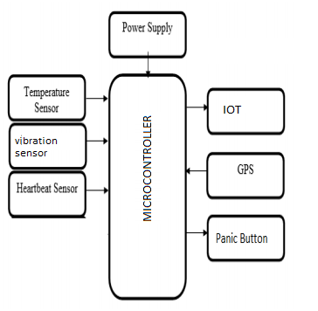

**Fig.1 Block diagram of**

**1.3 MODULES DESCRIPTION**

A module is a Hardware and software component or part of a program that contain one or more routines. One or more independently developed modules make up a program. The project “WOMEN SAFETY SYSTEM BY USING IOT” consists of two main modules they are,

* Hardware
* Software

**1.3.1 HARDWARE:**

1. **ARDUINO UNO**

The Microcontroller used here is an Arduino UNO. The UNO is a Microcontroller board based on ATMEGA 328P.

The ATMEGA 328P has 32kB of flash memory for storing code. The board has 14 digital input and output pins, 6 analog inputs, 16 MHz quartz crystal, USB, an ICSP circuit and a reset button. The UNO can be programmed with the Arduino software.

**2. SENSORS**

a sensor is a device, module, machine, or subsystem whose purpose is to detect events or changes depends upon tranducer in its environment and send the information to other electronics, frequently a microcontroller.A sensor is always used with other electronics**.**

**3. ESP8266 WIFI**

The ESP8266 arduino compatible module is a low-cost Wi-Fi chip with full TCP/IP capability, and the amazing thing is that this little board has a MCU (Micro Controller Unit) integrated which gives the possibility to control I/O digital pins via simple and almost pseudo-code like programming language. This device is produced by Shanghai-based Chinese manufacturer, Espressif Systems.

**4.GPS**

GPS or Global Positioning System is a satellite navigation system that furnishes location and time information in all climate conditions to the user. GPS is used for navigation in planes, ships, cars and trucks also. The system gives critical abilities to military and civilian users around the globe. GPS provides continuous real time, 3-dimensional positioning, navigation and timing worldwide.

**1.3.2 SOFTWARE SIDE**

# 1. [COLLECT](https://thingspeak.com/pages/how_to)

**SEND SENSOR DATA PRIVATELY TO THE CLOUD.**

There are sensors all around—in our homes, smart phones, automobiles, city infrastructure, and industrial equipment. Sensors detect and measure information on all sorts of things. And they communicate that data in some form, such as a numerical value or electrical signal.

### 1.1 WHY WOULD YOU WANT TO COLLECT DATA IN THINGSPEAK?

Sensors, or things, sense data and typically act locally. ThingSpeak enables sensors, instruments, and websites to send data to the cloud where it is stored in either a private or a public channel. ThingSpeak stores data in private channels by default, but public channels can be used to share data with others. Once data is in a ThingSpeak channel, you can analyze and visualize it, calculate new data, or interact with social media, web services, and other devices.

### 2.2 ANALYZE AND VISUALIZE YOUR DATA WITH MATLAB

Storing data in the cloud provides easy access to your data. Using online analytical tools, you can explore and visualize data. You can discover relationships, patterns, and trends in data. You can calculate new data. And you can visualize it in plots, charts, and gauges. Storing data in the cloud provides easy access to your data. Using online analytical tools, you can explore and visualize data. You can discover relationships, patterns, and trends in data. You can calculate new data. And you can visualize it in plots, charts, and gauges

### 2.3 WHY WOULD YOU WANT TO ANALYZE AND VISUALIZE DATA IN THINGSPEAK?

### Thingspeak Provides Access To Matlab To Help You Make Sense Of Data. You Can:

* Convert, combine, and calculate new data
* Schedule calculations to run at certain times
* Visually understand relationships in data using built-in plotting functions
* Combine data from multiple channels to build a more sophisticated analysis

# 2. [ACT](https://thingspeak.com/pages/how_to#act)

**2.1 TRIGGER A REACTION.**

Acting on data could be something as simple receiving a sensor (specified in Block) from arduino and data send to web server via Wifi module.

### WHY WOULD YOU WANT TO USE THINGSPEAK TO ACT ON DATA?

Thingspeak Provides Tools That Enable Device Communication For All Of These Actions And More. You Can:

* React to data—both raw data and new data that you calculate—as it comes into a channel
* Queue up commands for a device to execute

**CHAPTER-2**

**SYSTEM SPECIFICATION**

**2.1 HARDWARE SPECIFICATION**

* Microcontroller
* Motion Sensor
* Temperature Sensor
* Heart Beat Sensor
* Gps And Iot Device
* Panic Button
* Transformer
* Resistors
* Capacitors
* Diodes

**2.2 SOFTWARE SPECIFICATION**

* Arduino Compiler
* MC Programming Language: C
* IOT Gecko

**2.3 ABOUT THE SOFTWARE**

**FRONT END**

**PHP**

PHP stands for Hypertext Preprocessor. PHP scripts run inside Apache server or Microsoft IIS. PHP and Apache server are free. PHP code is very easy. PHP is the most used server side scripting language. PHP files contain PHP scripts and HTML. PHP files have the extension “php”, “php3”, “php4”, or “phtml”. Generate dynamic web pages. PHP can display different content to different user or display different content at different times of the day Process the contents of HTML forms. We can use an PHP to retrieve and respond to the data entered into an HTML form. Can create database-driven web pages. An PHP can insert new data or retrieve existing data from a database such a MySQL. PHP is a standard HTML file that is extended with additional features. Like a standard HTML file, PHP contains HTML tag that can be interpreted and displayed by a web browser. Anything we could normally place in an HTML file Java applets, Blinking text, server side scripts .we can place in PHP. However, PHP has three important features that make it unique. PHP contains server side scripts. PHP provides several built-in objects.

**HYPER TEXT MARKUP LANGUAGE (HTML)**

HTML is an application of the Standard Generalized Markup Language (SGML), which was approved as an international standard in the year 1986. SGML provides a way to encode hyper documents so they can be interchanged SGML is also a Meta language for formally describing document markup system. Infact HTML uses SGML to define a language that describes a WWW hyper document’s structure and inter connectivity. Following the rigors of SGML, TBL bore HTML to the world in 1990. Since then, many of us have it to be easy to use but sometimes quite limiting. These limiting factors are being addressed but the World Wide Web Consortium (aka W3c) at MIT. But HTML had to start somewhere, and its success argues that it didn’t start out too badly.

**PHP Syntax**

A PHP scripting block always starts with <?php and ends with ?>. A PHP scripting block can be placed anywhere in the document.

On servers with shorthand support enabled you can start a scripting block with <? And end with ?>.

For maximum compatibility, we recommend that you use the standard form (<?php) rather than the shorthand form.

A PHP file normally contains HTML tags, just like an HTML file, and some PHP scripting code.each code line in PHP must end with a semicolon.

The semicolon is a separator and is used to distinguish one set of instructions from another

**BENEFIT OF PHP**

• **Cross Platform**

All the PHP based applications can run on various types of platforms. PHP is supported by majority of Operating Systems, some of which includes Solaris, UNIX, Windows and Linux. The mentioned platforms can be used to write codes in PHP and also view web pages or run the PHP based applications.

**• Easy database connection**

A programming language like PHP is widely used on the internet and needs to connect to the database very often. Therefore, having a feature that could help PHP to connect to database easily is mandatory. Several websites such as the ecommerce websites, require good database management system.

**• Easy to use**

PHP is widely used because it is easy to use. In contrast with other programming languages that are complex, PHP is simple, fluent, clean and organized, hence it is a boon for the new users. PHP has a well-organized syntax which is logical at the same time.

The high speed of PHP gives it an advantage over other scripting languages and gives it an application in important administrations such as the server administration and mail functionalities.

**• Open source**

One of the important advantages of PHP is that it is Open Source. Therefore, PHP is readily available and is entirely free. In contrast to other scripting languages used for web development which requires the user to pay for the support files, PHP is open to everyone, anytime and anywhere. PHP is maintained and developed by a large group of PHP developers which helps in creating support community of PHP that helps people in PHP implementation and manipulation.

**BACK END**

**MYSQL SERVER**

**Database**

A database is simply a collection of used data just like phone book. MySQL database include such objects as tables, queries, forms, and more.

**Tables**

In MySQL tables are collection of similar data. With all tables can be organized differently, and contain mostly different information- but they should all be in the same database file. For instance we may have a database file called video store. Containing tables named members, tapes, reservations and so on. These tables are stored in the same database file because they are often used together to create reports to help to fill out on screen forms.

**Relational database**

MySQL is a relational database. Relational databases tools like access can help us manage information in three important ways.

• Reduce redundancy

• Facilitate the sharing of information

• Keep data accurate

**Fields**

Fields are places in a table where we store individual chunks of information.

**Primary key and other indexed fields**

MySQL use key fields and indexing to help speed many database operations. We can tell MySQL, which should be key fields, or MySQL can assign them automatically.

**Controls and objects**

Queries are access objects us display, print and use our data. They can be things like field labels that we drag around when designing reports. Or they can be pictures, or titles for reports, or boxes containing the results of calculations.

**Queries and dynasts**

Queries are request to information. When access responds with its list of data, that response constitutes a dynast. A dynamic set of data meeting our query criteria. Because of the way access is designed, dynasts are updated even after we have made our query.

**Forms**

Forms are on screen arrangement that make it easy to enter and read data. we can also print the forms if we want to. We can design form our self, or let the access auto form feature.

**Reports**

Reports are paper copies of dyna sets. We can also print reports to disk, if we like. Access helps us to create the reports. There are even wizards for complex printouts.

**Properties:**

Properties are the specification we assigned to parts of our database design. We can define properties for fields, forms, controls and most other access objects.

**FEATURES OF MYSQL**

• MYSQL is a relational database system. If you can believe many diehard MYSQL fans, MYSQL is faster, more reliable, and cheaper -- or, simply put, better -- than any other database system (including commercial systems such as Oracle and DB2).

• Many MYSQL opponents continue to challenge this viewpoint, going even so far as to assert that MYSQL is not even a relational database system. We can safely say that there is a large bandwidth of opinion.

• The fact is that there is an ever increasing number of MYSQL users, and the overwhelming majority of them are quite satisfied with MYSQL. Thus for these users we may say that MYSQL is good enough.

• It is also the fact, however, that MYSQL still lacks a number of features that are taken for granted with other database systems.

• If you require such features, then MYSQL is (at least for the present) not the database system for you. MYSQL is not a panacea.

• The following list shows the most important properties of MYSQL. This section is directed to the reader who already has some knowledge of relational databases. We will use some terminology from the relational database world without defining our terms exactly. On the other hand, the explanations should make it possible for database novices to understand to some extent what we are talking about.

• Relational Database System: Like almost all other database systems on the market, MYSQL is a relational database system.

• Client/Server Architecture: MYSQL is a client/server system. There is a database server (MYSQL) and arbitrarily many clients (application programs), which communicate with the server; that is, they query data, save changes, etc. The clients can run on the same computer as the server or on another computer (communication via a local network or the Internet).

• the familiar large database systems (Oracle, Microsoft SQL Server, etc.) are client/server systems. These are in contrast to the file-server systems, which include Microsoft Access, dBase and FoxPro. The decisive drawback to file-server systems is that when run over a network, they become extremely inefficient as the number of users grows.

**CHAPTER-3**

**SYSTEM STUDY**

**3.1 EXISTING SYSTEM**

There are few already created devices and products in market that are related to our research. Following are the few examples of the

existing systems/devices:

1. ROAR (Athena)

2. Foot wear chip

3. Shake2Safety

III. DRAWBACKS OF EXISTING DEVICES

There existed a chip that was sticked to the footwear and was used to send the alerts. The other research showed up with the smart band that was used to generate the SOS signals along with the personal health information and based on that the alert was generated

All the devices were used to sense the health parameters and positions of the body and accordingly, the alerts and SOS signals were sent to the contacts feeded

**3.2 PROPOSED SYSTEM**

We have developed a prototype that is a smart device that can be worn by any individual on their wrists. The band is always active, the victim needs to tap on the screen twice when she feels the need of it or she feels someone is abusing her. After tapping on the button, the device will start sending the current latitudinal and longitudinal co-ordinates to the near ICE contacts and the police controlroom.. All sensor reading continuously and send to webserver via IOT device. In this system we use, Arduino UNO acts as main controller which continuously get data from sensor . By using the microcontroller we can able to set the threshold value. If it reaches the threshold value it sends the notification to the user.

**CHAPTER-4**

**SYSTEM DESIGN**

**4.1 DATA FLOW DIAGRAM**

System design is the process of planning a new system or to replace the existing system. Simply, system design is like the blueprint for building, it specifies all the features that are to be in the finished product. System design phase follows system analysis phase. Design is concerned with identifying functions, data streams among those functions, maintaining a record of the design decisions and providing a blueprint the implementation phase.

Design is the bridge between system analysis and system implementation. Some of the essential fundamental concepts involved in the design of application software are:

• Abstraction

• Modularity

• Verification

A data flow diagram is graphical tool used to describe and analyze movement of data through a system. These are the central tool and the basis from which the other components are developed. The transformation of data from input to output, through processed, may be described logically and independently of physical components associated with the system. These are known as the logical data flow diagrams. The physical data flow diagrams show the actual implements and movement of data between people, departments and workstations. A full description of a system actually consists of a set of data flow diagrams. The development of DFD’S is done in several levels.

**TRANSMITTER SIDE:**

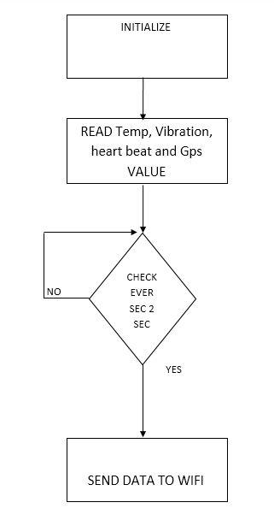

Fig.2 Block diagram of the Transmitter side

**RECIVER SIDE:**

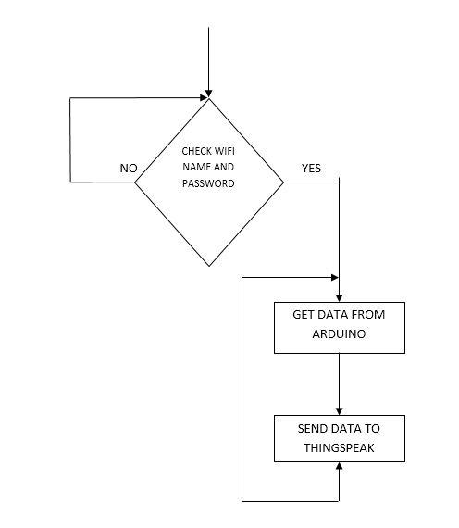

Fig.3 Block diagram of Receiver side

|  |  |  |  |  |
| --- | --- | --- | --- | --- |
| Field Name | Attribute | Type | Size | Description |
| Id | Primary key | Int | 10 | It uniquely store id in the table |
| Temperature | Null | Int | 12 | It store temperature of the women safety |
| vibration | Null | Int | 12 | It store vibration of the women safety |
| Heart beat | Null | Int | 12 | It Store Heart beat pulse of the women safety |
| Latitude | Null | VarChar | 50 | It store Gps Latitude of the women safety |
| Longitude | Null | VarChar | 50 | It store Gps Longitude of the women safety |

**4.2 TABLE DESIGN**

Table Name: woman safety system by using IOT

Table Description: This table stored women safety information

**4.3 INPUT DESIGN**

Input design is one of the most expensive phases of the operation of computerized system and is often the major problem of a system. A large number of problems with the system can usually be traced back to fault input design and method. Needless to say, therefore that the input data is the life block of a system and has to be analyzed and designed with the most consideration.

The decisions made during the input design are:

• To provide cost effective method of input.

• To achieve the highest possible level of accuracy.

• To ensure that input is understood by the user.

System analysts decide the following input design details like, what data item to input, what medium to use, how the data should be arranged or coded data items and transaction needing validations to detect errors and at last the dialogue to guide users in providing input. Input data of a system may not be necessarily a raw data captured in the system form scratch. These can also be the output of another system or sub-system. The design of input covers all phases of input from the certain of initial data to actual entering the data to the system for processing.

**4.4 OUTPUT DESIGN**

Output design generally refers to the results and information that are generated by the system. For many end-users, output is the main reason for developing the system and the basis on which they evaluate the usefulness of the application.

The objective of a system finds its shape in terms of output. The analysis of the objective of a system leads to determination of outputs. Outputs of a system can take various forms. The most common are reports, screens displays printed form, graphical drawing etc. the outputs vary in terms of their contents, frequency, timing and format. The users of the output, its purpose and sequence of details to be printed are all considered. When designing output, the system analyst must accomplish things like, to determine what information to be present, to decide whether to display or print the information and select the output medium to distribute the output to intended recipients.

Internal outputs are those, whose destination is within the organization. It is to be carefully designed, as they are the user’s main interface with the system. Interactive outputs are those, which the user uses in communication directly with the computer.

**CHAPTER-5**

**SYSTEM TESTING AND IMPLEMENTATION**

**TESTING AND METHODOLOGIES**

System testing is the stage before system implementation where the system is made error free and all the needed modifications are made. The system was tested with test data and necessary corrections to the system were carried out. All the reports were checked by the user and approved. The system was very user friendly with online help to assist the user wherever necessary.

**TEST PLAN**

A test plan is a general document for the entire project, which defines the scope, approach to be taken, and schedule of testing, as well as identifying the test item for the entire testing process, and the personal responsible for the different activities of testing. This document describes the plan for testing, the knowledge management tool.

Major testing activities are:

* + - Test units
    - Features to be tested
    - Approach for testing
    - Test deliverables
    - Schedule
    - Personal allocation

**TEST UNITS**

Test Case specification is major activity in the testing process. In this project, I have performed two levels of testing**.**

* Unit testing
* System testing

The basic units in Unit testing are

* Validating the user request
* Validating the input given by the user
* Exception handling

The basic units in System testing are

* Integration of all programs is correct or not
* Checking whether the entire system after integrating is working as expected.
* The system is tested as whole after the unit testing.

**TEST DELIVERABLES**

The following documents are required besides the test plan

* Unit test report for each unit
* Test case specification for system testing
* The report for system testing
* Error report

The test case specification for system testing has to be submitted for review before the system testing commences.

**TEST CASE AND TEST REPORTS**

**UNIT TESTING**

The system is tested as whole after the unit testing.

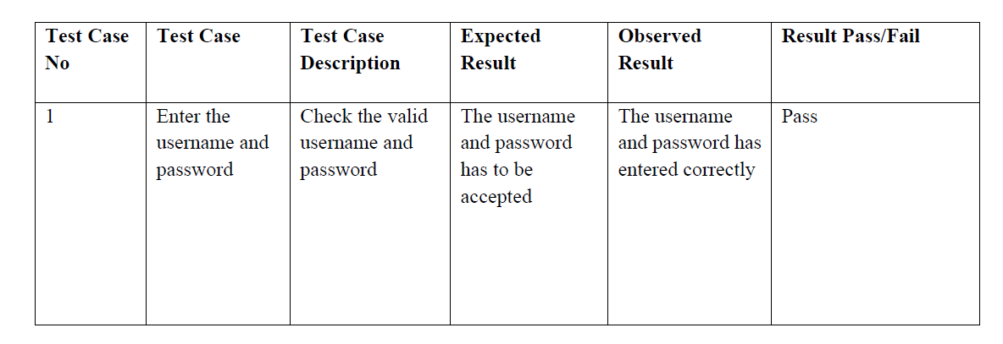

**VALIDATION TESTING**

The objectives of this testing is to tell user about the validity and the reliability of the system

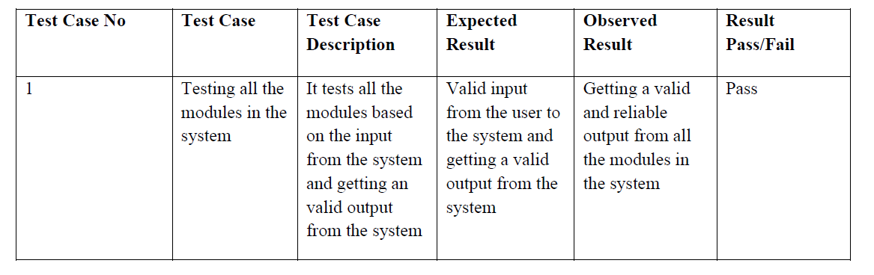

**SYSTEM TESTING**

Entire system is tested as per the requirements. Black-box type testing that is based on the overall requirements, covers all combined parts of a system.

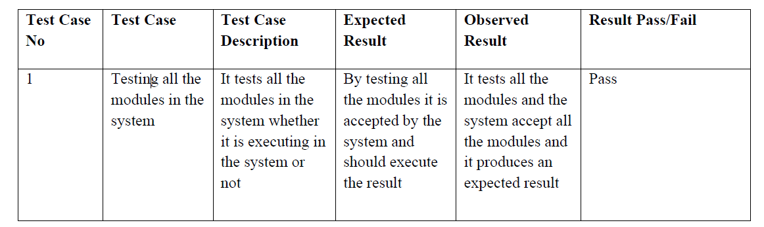

**INTEGRATION TESTING**

This type of testing is especially relevant to client/server and distributed systems.

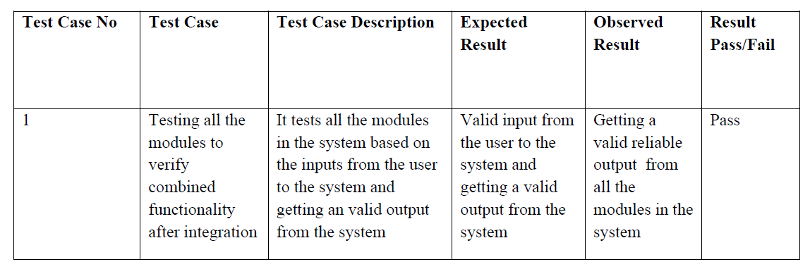

**5.2 SYSTEM IMPLEMENTATION**

System Implementation is the stage of the project when the theoretical design is tuned into working system. If the implementation system stage is not carefully controlled and planned, it can cause chaos. Thus it can be considered to be the most critical stage in achieving a successful new system and in giving the users a confidence that the system will work and be effective.

The implementation stage in a project involves,

* Careful Planning investigation of the current system, checking constraints and the implementation.
* Training the staffs in the newly developed system.

A software application in general is implemented after navigating the complete life cycle method of a project. Various life cycle processes such as requirement analysis, design phase, verification, testing and finally followed by the implementation phase results in a successful project management. The software application which is basically a Windows based application has been successfully implemented after passing various life cycle processes mentioned above.

As the software is to be implemented in a high standard industrial sector, various factors such as application environment, user management, security, reliability and finally performance are taken as key factors throughout the design phase. These factors are analyzed step by step and the positive as well as negative outcomes are noted down before the final implementation.

Security and authentication is maintained in both user level as well as the management level. The data is stored in MySQL, which is highly reliable and simpler to use, the user level security is managed with the help of password options and sessions, which finally ensures that all the transactions are made securely.

The application’s validations are made, taken into account of the entry levels available in various modules. Possible restrictions like number formatting, date formatting and confirmations for both save and update options ensures the correct data to be fed into the database. Thus all the aspects are charted out and the complete project study is practically implemented successfully for the end users.

**CHAPTER-6**

**CONCLUSION**

The occurrence of threats to women leads to increase in number of security devices and applications. This research shows the various factors which have been used in applications and smart devices developed for women safety. In this paper, the various techniques used so far for the sake of women safety against the fraudulent people have been discussed. Also a brief explanation about the devices and components used in these techniques are also provided.

**CHAPTER-7**

**FUTURE ENHANCEMENT**

In future, we can add shooting of video at the time of the emergency that helps in reaching the criminal very easily. It also provides an evidence against the criminal. We can also save the photos and videos on the drive so that it will be easy for further any used. Prototype can be further calibrated into a complete market product which will be made with chips and utility hardware so that it can be attached to the public transport vehicles that will help every person to know about the location of their near and dear ones. We can also capture and send photos to the registered number in the applications along with the location.

**BIBLIOGRAPHY**

**REFERENCE**

1. Internet of things (http://en.wikipedia.org/wiki/Internet-of-Things)

2. CoiNet Technology solutions LLP, LPC2148 ARTIST Instruction manual

3. Digital.csic.es/bitstream/10261/127788/7/D-C-%20Arduino%20uno

4. ESP8266 802.11bgn Smart Device/Expressifsystems/October 2013

5. Nishant Bhardwaj and Nitish Aggarwal “Design and

Development of - Suraksha”ı IEEE International Journal of

Information & Computation Technology, Volume 4,

6. Thingspeak ([www.Thingspeak.co.in](http://www.thingspeak.co.in))

7. Dantu Sai Prashanth, Gautam Patel, Dr.B.Bharathi “Research and

development of a mobile based women safety application with realtime

database and data-stream network” IEEE International

Conference on ciruits power Aand computing technologies, ISBN

978-1- 5090-4967- 7, 2018.